Achieving perfect secrecy in the modern days

Ang Ming Yi
School of Computing
National University of Singapore
13 Computing Dr, 177417
+65 65162727
ming_yi@u.nus.edu
Pang Yong He
School of Computing
National University of Singapore
13 Computing Dr, 177417
+65 65162727
yonghe@u.nus.edu
Kaung Htet Aung
School of Computing
National University of Singapore
13 Computing Dr, 177417
+65 65162727
kaung_htet@u.nus.edu
Yeo Quan Yang
School of Computing
National University of Singapore
13 Computing Dr, 177417
+65 65162727
quanyang@u.nus.edu
Koh Jun Xiang
School of Computing
National University of Singapore
13 Computing Dr, 177417
+65 65162727
kohjx@u.nus.edu

ABSTRACT
In this paper, we describe a proof-of-concept encryption scheme in which secret keys are generated from publicly available data.
Categories and Subject Descriptors
D.4.6 [Security and Protection] (K.6.5): Authentication, Cryptographic controls
E.4 [Coding and Information Theory]: Nonsecret encoding schemes
General Terms
Algorithms, Performance, Design, Experimentation, Security
Keywords
Perfect Secrecy, Entropy, Digital Media, Encryption scheme

INTRODUCTION
Data is mainly being encrypted using symmetric encryption schemes using much less bits than the asymmetric counter part. Despite the difference in bits, the security is considered equivalent. The caveat is that symmetric keys must be agreed upon before hand. In this paper, we aim to design a scheme that the only involves an initial key agreement and will allow two parties to communicate as securely as existing schemes without the need to always renew the agreed key.

Idea

Components
The key components in our project are the two parties that require secure communication, the encryption scheme, and the proof-of-concept program that implements our encryption scheme.

Simplification
Instead of providing fully featured GUI software, we will be providing a simplified proof-of-concept version of the software where the users are required to know the constraints manually when starting an encryption process. Also, although our current encryption scheme generates and uses a 512-bit key, it is scalable to a 4096-bit key version in the future.

Key concept
The concept of our encryption scheme is to turn publicly available data into a suitable shared session key between two parties through a series of functions. By using publicly available data, such as videos and compressed files, we would be able to use them as a form of one-time pad (OTP) during encryption, and subsequently, decryption. The key idea is to mimic the one-time pad (OTP) encryption technique such that it is not possible to crack the encryption without an exhaustive brute force on every encrypted data transfer session.

Assumptions
We assume that the following are true:
- The two parties are able to agree on an initial shared secret key before using our encryption scheme.
- The two parties are able to both access and download the same publicly available data on the Internet.

Encryption Scheme

Introduction
In the previous section, we have highlighted the aim of eliminating the need of initial pre-shared secret key renewal. In our encryption scheme, with the use of Exclusive or (XOR) operations and hashing algorithm, the shared secret key is manipulated into a unique session key for each session, eliminating the need to re-establish a new pre-shared secret key for each session.
The underlying design of our encryption scheme is based on the concept of a block cipher in which the encryption would operate on a fixed-length of bits. In our proof-of-concept version, the block size is fixed at 512-bits.
Two modes of operation, namely Electronic Codebook (ECB) and Cipher Block Chaining (CBC), has been explored and implemented in our encryption scheme to encrypt data larger than the block size.
In each block, the generation of the session block key is done with an algorithm performing a series of block chaining operations from the session secret key through blocks of Internet files to compute the final session block key.
Last but not least, the final session block key would be XOR’ed with a block of the plaintext to output a block of ciphertext.

Design
In this section, we will explain our encryption scheme in details through design diagrams.
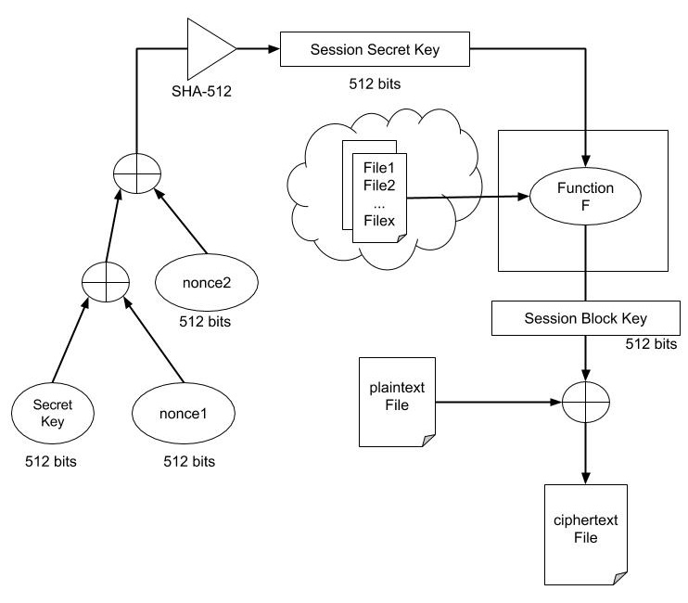
Figure 3-1 Encryption Scheme
The typical flow of our encryption scheme is depicted in the Figure 3-1.
Name | Description
Secret Key | The initial 512-bits pre-shared secret key
nonce1 | A randomized 512-bits value for the session
nonce2 | A randomized 512-bits value for the session
SHA-512 | The hashing algorithm used to produce 512-bits Session Secret Key
Session Secret Key | A 512-bits protected secret key for the session
File1, File2... Filex | The files taken from the internet, e.g youtube video files
Function F | The function responsible in computing the final session block key
Session Block Key | The final session block key for the session
Plaintext File | The file to be encrypted.
Ciphertext File | The encrypted file.
The initial pre-process consists of XOR operations performed on the secret key, nonce1 and nonce2 values. SHA-512 hashing algorithm is an additional step used to ensure that the secret key goes through further transformation.
The purpose of the pre-process is to protect the secret key from any chosen-plaintext attack, known-plaintext attack and chosen-ciphertext attack. With a drastically change in the secret key for every session, it would be hard for the attackers to recover the secret key, thus, allowing the possibility of reusing the pre-shared secret key from the initial key agreement without the fear of exposing the secret key.
Now, with the session secret key ready, it is time to feed it into the core function of our encryption scheme, function F.
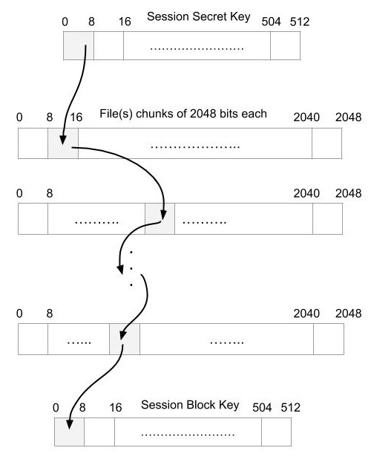
Figure 3-2 Function F
The block chaining operation of the function F is shown in Figure 3-2. The 512-bits session secret key and the 2048-bits file chunks are split into bytes block, with 128 and 256 blocks respectively.
The block chaining start from a block of the session secret key, yielding a block index from the byte. This block index would be “chain” to the next block in the file chunk, which in turn yields another block index from the byte. This block chaining would repeatedly be done until the last file chunk, which would be used to form part of the session block key – the location of this byte would correspond to the location of the relevant block of session secret key for this chaining operation.
In total, the session secret key would go through 64 rounds of block chaining operation to complete a session block key, starting with the first byte of session secret key.
Each Internet file provided is only being used for one chain step, e.g. 1 file provides 1 chain step, 3 files provide 3 chain steps. The file would be split into 2048-bits chunk(s), the number of chunks is dependent on the number of blocks needed for the plaintext file- every 64 bytes of plaintext requires a 2048-bits chunk for encryption.
Therefore, the following conditions would applied to compute the session block key for each block of the plaintext file:
- The session secret key remained unchanged.
- The file(s) chunks used for chaining would be changed.
- The session secret key has to go through another 64 rounds of block chaining operation.
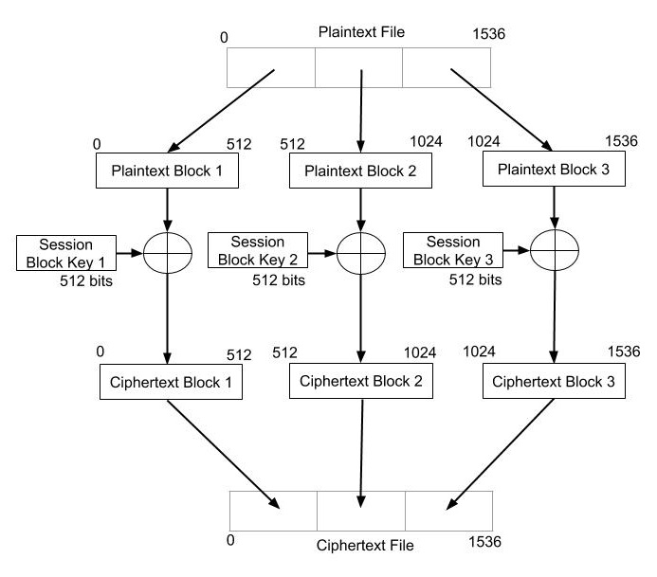
Figure 3-3 ECB
The mode of operation, ECB, for our encryption scheme is illustrated in Figure 3-3. The plaintext file is divided into blocks, and each block is XOR’ed with a session block key to output a cipbertext block. All the ciphertext blocks are then concatenated to get a ciphertext file.
In a normal ECB mode, the given key is used to encrypt all the blocks making the encryption deterministic since any identical plaintext block always get encrypted to the same ciphertext block. For the reason, it is always recommended to use other mode of operations, such as CBC, other than ECB mode.
However, in our encryption scheme, a new block key is generated for each block of plaintext file, which give the ability of making the encryption non-deterministic just like CBC mode. Any given plaintext block would not always get encrypted to the same ciphertext block, thus providing message confidentiality.

Implementation
The key components in our project are the two parties that require secure communication

Results
As discussed earlier, the encryption is non-deterministic for the ECB mode in our encryption scheme. We would now use our implementation to demonstrate this characteristic with few examples.
The steps to compute the Session Secret Key in Figure 3-1 and the steps to compute Session Block Key in Figure 3-2 would be omitted to give a clearer illustration of the non-deterministic characteristic.
For easier comparison of the encrypted blocks, we would assume the same Session Secret Key in all examples. The combination of Internet files would be changed to see the effects of Function F and ECB mode on the encrypted blocks.
With reference to Figure 3-3, we would show a few scenarios with different changing factor.
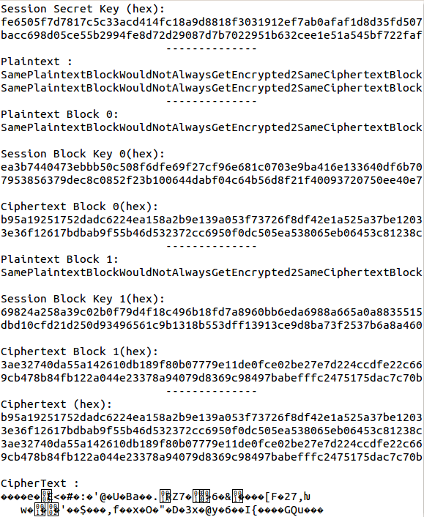
Scenario 1 with Internet file 1 to show our ECB mode make two identical plaintext block encrypted to different ciphertext block
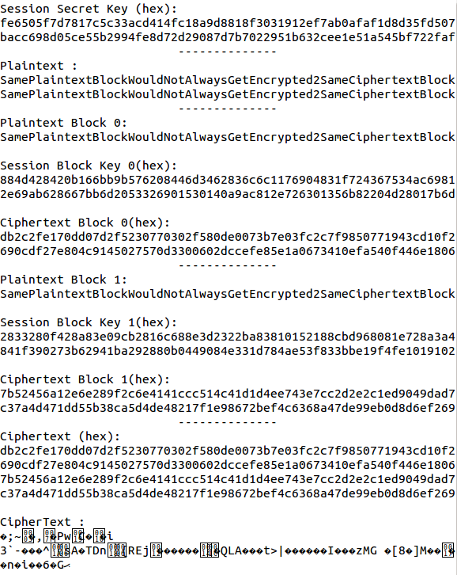
Scenario 2 with Internet file 2 to show the effect of a different Internet file would result in a different session block keys for the block 1 and 2 due to Function F.
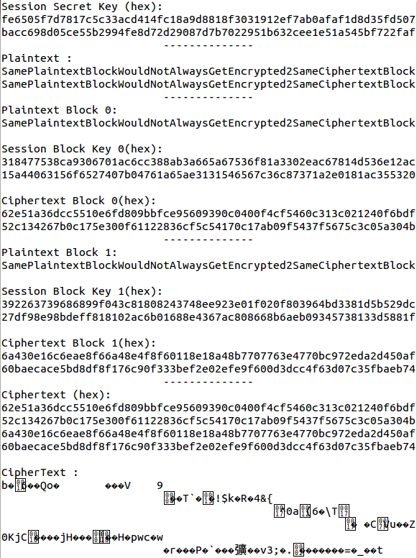
Scenario 3 with Internet file 1 and Internet file 2 to show the effect of 2 steps block chaining operation in Function F.
With these scenarios, we can see that any given plaintext block would not always get encrypted to the same ciphertext block. In addition, the nonce1 and nonce2 are randomized in each session. Given a scenario where the user decide to encrypt the same plaintext with same files, the end result would be a completely different ciphertext too.
More detailed analysis and evaluation on the strength of the individual encrypted block and our encryption scheme would be covered later in the section 5.

Entropy of Media formats
Description of this section.

Differences between formats
The heading of subsections should be in Times New Roman 12-point bold with only the initial letters capitalized. (Note: For subsections and subsubsections, a word like the or a is not capitalized unless it is the first word of the header.)

MKV
The heading for subsubsections should be in Times New Roman 11-point italic with initial letters capitalized and 6-points of white space above the subsubsection head.

AVI
The heading for subsubsections should be in Times New Roman 11-point italic with initial letters capitalized.

ZIP
The heading for subsubsections should be in Times New Roman 11-point italic with initial letters capitalized.

Discussion
Certain media format is shown not to be suitable for use with our scheme. Why. What should we use instead.

Testing of Encryption Scheme
asd

Testing Strategies
Certain media format is shown not to be suitable for use with our scheme. Why. What should

Tests conducted
Certain media format is shown not to be suitable for use with our scheme. Why. What should

Frequency Test
The heading for subsubsections should be in Times New Roman 11-point italic with initial letters capitalized and 6-points of white space above the subsubsection

Entropy Test
The heading for subsubsections should be in Times New Roman 11-point italic with initial letters capitalized and 6-points of white space above the subsubsection

Image test
The heading for subsubsections should be in Times New Roman 11-point italic with initial letters capitalized and 6-points of white space above the subsubsection

Tests results
Certain media format is shown not to be suitable for use with our scheme. Why. What should

Frequency Test
The heading for subsubsections should be in Times New Roman 11-point italic with initial letters capitalized and 6-points of white space above the subsubsection

Entropy Test
The heading for subsubsections should be in Times New Roman 11-point italic with initial letters capitalized and 6-points of white space above the subsubsection

Image test
The heading for subsubsections should be in Times New Roman 11-point italic with initial letters capitalized and 6-points of white space above the subsubsection

Discussion
So what happened in the test

Conclusion
Finally, we conclude that this deserves 10/10.

ACKNOWLEDGMENTS
Our thanks to Prof. Hugh Anderson for allowing us to design and develop our own encryption scheme.

REFERENCES
- Blahblah.
- Blahblah.

- Blahblah.
- Blahblah.

- Blahblah.

- Blahblah.

- Blahblah.

- Blahblah.

- Blahblah.

